Reception House Staff:

- Gayatri, Life-Skills Facilitator
“As we celebrate National Volunteer Week 2024 under the theme "Every Moment Matters”, we want to extend our heartfelt gratitude to each volunteer at the Reception House Waterloo Region. Your dedication, hard work, and generosity embody the spirit of this theme, illustrating how vital every moment of volunteering is, especially at a time when support is more crucial than ever. The sharing of your time, skills, empathy, and creativity has been instrumental in fostering an inclusive, strong, and well community, significantly impacting the lives of newcomers to Canada. Your efforts have made their transition smoother, helping them to start their new life with hope and confidence. The success of our program hinges on your unwavering support; without it, our goals would remain out of reach.
Big thankyou and appreciation go to our client volunteers, Your tireless efforts and swift action upon arriving at our temporary accommodation have played a vital role in shaping the success we enjoy today. Your dedication and selflessness have not only touched our hearts but have also significantly impacted our clients, and community. We extend our sincerest appreciation for your unwavering commitment and invaluable contributions. Thank you for exemplifying kindness and compassion in every interaction. Your generosity and support have made a lasting difference, and for that, we are eternally grateful. Thank you for every moment you've dedicated, for every life you've touched, and for making a difference when it matters most!”

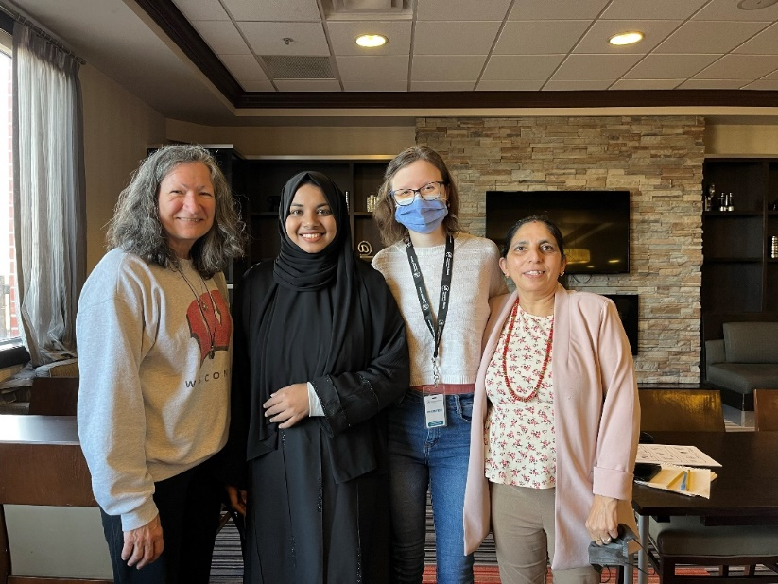
(Pic from left-right) Volunteers: Arlene White, Rahiman(aka Khushi) Khatun, Felicia Clement and Life Skills Facilitator Gayatri Nepal for English Conversation Circle

- Mohammed, Youth Facilitator
“On Behave of Reception House youth program, I want to take a moment to express my heartfelt gratitude for your dedicated help as a volunteer in our program. Your enthusiasm and commitment have made a significant impact for many of our youth, as they settle in their new community. Once again thank you for choosing to volunteer with Reception House and we look forward to continuing this journey, together.”
- Sahara, Childrens Program Facilitator
“I want to say thank you to all the children's program volunteers. Your enthusiasm, patience, and kindness has been a great addition to the program. The children truly enjoyed your ability to cater to their needs when working on a task. Without your helps, the program wouldn't have been able to run smoothly. Your time, creativity and effort is truly appreciated. Thank you.”
- Narayani Pradhan, Volunteer and Donations Coordinator
“I value every moment I get to experience with diverse volunteers that comes to the organization to support our various program. The passion, enthusiasm, talents, and abilities the volunteers bring to share with ours is what I cherish while onboarding all the volunteers. Reception House Volunteers are the heroes giving back to the community and making real differences in the lives of the government assisted refugees.”

- Hanan Thibeh, Volunteer/Community Connection Coordinator
“Connecting with other volunteers on my first day is a moment I will always remember! I was extremely nervous engaging with a new group of people and I was franticly looking around for help. Thank goodness I caught the eye of a fellow volunteer who smiled and came over to help. I felt such an overwhelming amount of support and care during this moment. It will always have a special place in my heart.

